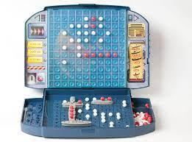 Final Summative – Battleship Tournament 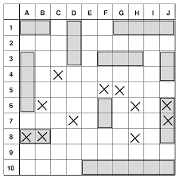

Name: Aiden Wang

| Date | Tasks/Progress |
| --- | --- |
| Jan. 11, 2022 | Completed Project Charter for initiation.  Contributed to algorithm writing. (at least 50% done) |
| Jan. 12, 2022 | Worked on the Planning Phase (completed 50%)  Worked on GANTT Chart (completed 50%) |
| Jan. 13, 2022 | Completed Planning Documents (Scope, Change Management Steps)  Worked on Algorithms (100% complete)  Worked on GANTT Chart (100% complete) |
| Jan. 14, 2022 | Started to work on the Easy AI targeting code (50%) |
| Jan. 17, 2022 | Started to work on the Expert AI targeting code (20%) |
| Jan. 18, 2022 | Worked on the Expert AI targeting code (70%)  Worked on the Easy AI targeting code (90%) |
| Jan. 19, 2022 | Finished Expert AI Targeting Code (100%)  Finished Easy AI Targeting Code (100%) |
| Jan. 20, 2022 | Debugging and reviewing the code (looking for potential improvements)  Improved layout and visual of the game |
| Jan. 21, 2022 | Modified the expert AI targeting code (100% complete)  Discussed this modification with members, recorded in the Changement document |